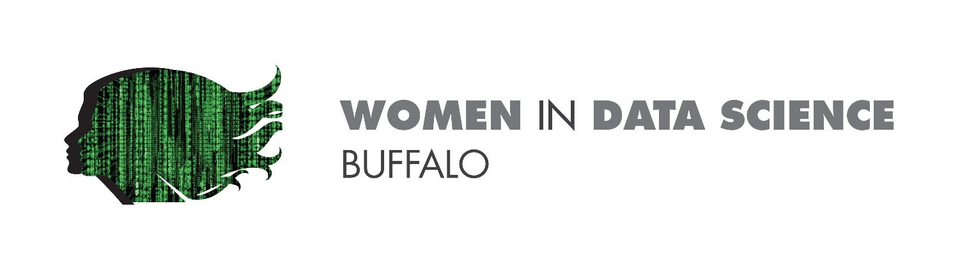

AGENDA- DAY 1

SATURDAY, 30TH JANURARY, 2020

|  |  |
| --- | --- |
| 11:00-11:15 | WELCOME & OPENING REMARKS  Lama Moukheiber, WiDS Ambassador  WiDS Stanford Opening Video |
| 11:15-12:45 | KEYNOTE  How the pandemic has shifted healthcare innovation priorities, lessons learnt and path ahead  Ashima Gupta, Director, Global Healthcare Strategy and Solutions, Google Cloud |
| 12:45-1:30 | PANEL DISCUSSION  The Expanding Role of AI in Healthcare  Panelists   1. Ashveena Gajeelee 2. Nina Kottler 3. Bonnie Clipper 4. Nadine Hachach-Haram |
| 1:30-1:45 | BREAK |
| 1:45-2:15 | Keynote  Sandy Carter, Vice President at Amazon Web Services |
| 2:15-3:00 | PANEL DISCUSSION  The Data Science Spectrum in Cross-industry  Panelists   1. Karin Jenson 2. Tannaz Khaleghi 3. Sheila Ambruster 4. Jo Ann Tan |
| 3:00-3:15 | CLOSING REMARKS  Lama Moukheiber, WiDS Ambassador |

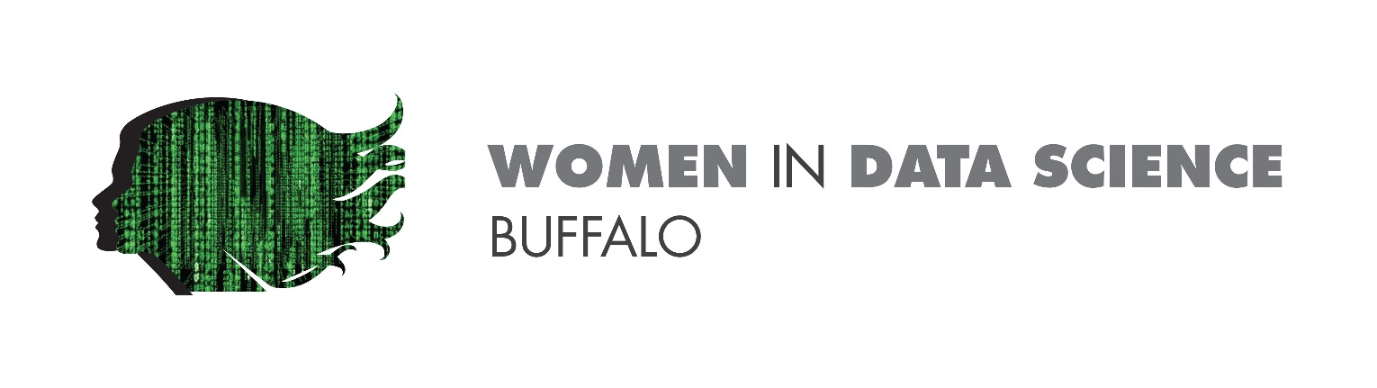AGENDA- DAY 2

Sunday, 31TH JANURARY, 2020

|  |  |
| --- | --- |
| 11:00-11:15 | Introduction & Welcome  Lama Moukheiber, WiDS Ambassador |
| 11:15-12:45 | KEYNOTE  Sarmila BasuHead of Data Science for Microsoft Consulting Services |
| 12:45-1:30 | PANEL DISCUSSION  Driving Digital Transformation through Innovation  Panelists   1. Kristen McGarry 2. Silvina Moschini 3. Corin Keid 4. Victoria Stasiewicz |
| 1:30-1:45 | Data Robot Demo  Cory Reid, Customer Facing Data Scientist at DataRobot |
| 1:45-2:30 | BREAK |
| 2:30-2:50 | PANEL DISCUSSION  Achieving AI Fairness, Robustness and Explainability   1. Ann-elise Delbecq 2. Curren Katz 3. Sian Lewis |
| 2:00-3:15 | CLOSING REMARKS  Lama Moukheiber, WiDS Ambassador |